**Assignment 3 – My Movies**

Using Apriori algorithm: Below are the 3 steps to be accomplished for the assignment and necessary solution is being provided in the subsequent sections

**Problem Statement:**

Prepare rules for the all the data sets

1) Try different values of support and confidence. Observe the change in number of rules for different support, confidence values

2) Change the minimum length in apriori algorithm

3) Visualize the obtained rules using different plots

**Solution:**

Step 1: Try different values of support and confidence. Observe the change in number of rules for different support, confidence values

#1st rule - Actual data for association is available from 6th column onwards,

#hence we have the column specificiation - [,6:15]

Movies_rules <- apriori(as.matrix(Movies_data[,6:15]),parameter = list(support = 0.02,confidence = 0.5,minlen=4))

|  |
| --- |
| > Movies_rules <- apriori(as.matrix(Movies_data[,6:15]),parameter = list(support = 0.02,confidence = 0.5,minlen=4))  Apriori  Parameter specification:  confidence minval smax arem aval originalSupport maxtime support minlen maxlen  0.5 0.1 1 none FALSE TRUE 5 0.02 4 10  target ext  rules FALSE  Algorithmic control:  filter tree heap memopt load sort verbose  0.1 TRUE TRUE FALSE TRUE 2 TRUE  Absolute minimum support count: 0  set item appearances ...[0 item(s)] done [0.00s].  set transactions ...[10 item(s), 10 transaction(s)] done [0.00s].  sorting and recoding items ... [10 item(s)] done [0.00s].  creating transaction tree ... done [0.00s].  checking subsets of size 1 2 3 4 5 done [0.00s].  writing ... [29 rule(s)] done [0.00s].  creating S4 object ... done [0.00s]. |

> inspect(head(sort(Movies_rules, by = "lift")))

lhs rhs support confidence lift

[1] {Sixth.Sense,Gladiator,Green.Mile} => {LOTR} 0.1 1 10

[2] {Sixth.Sense,Gladiator,LOTR} => {Green.Mile} 0.1 1 5

[3] {LOTR1,Harry.Potter1,LOTR2} => {Green.Mile} 0.1 1 5

[4] {LOTR1,Harry.Potter1,Green.Mile} => {LOTR2} 0.1 1 5

[5] {LOTR1,LOTR2,Green.Mile} => {Harry.Potter1} 0.1 1 5

[6] {Harry.Potter1,LOTR2,Green.Mile} => {LOTR1} 0.1 1 5

count

[1] 1

[2] 1

[3] 1

[4] 1

[5] 1

[6] 1

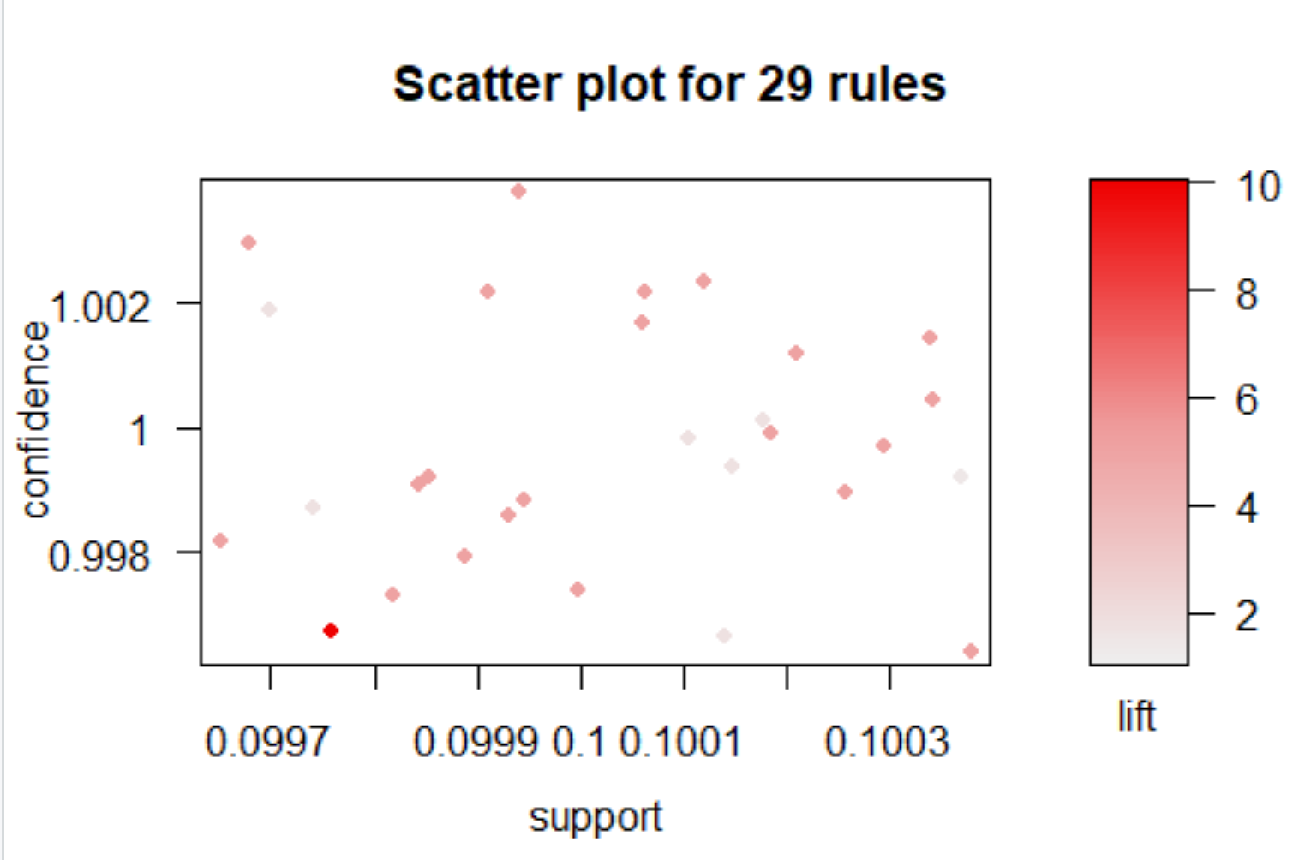

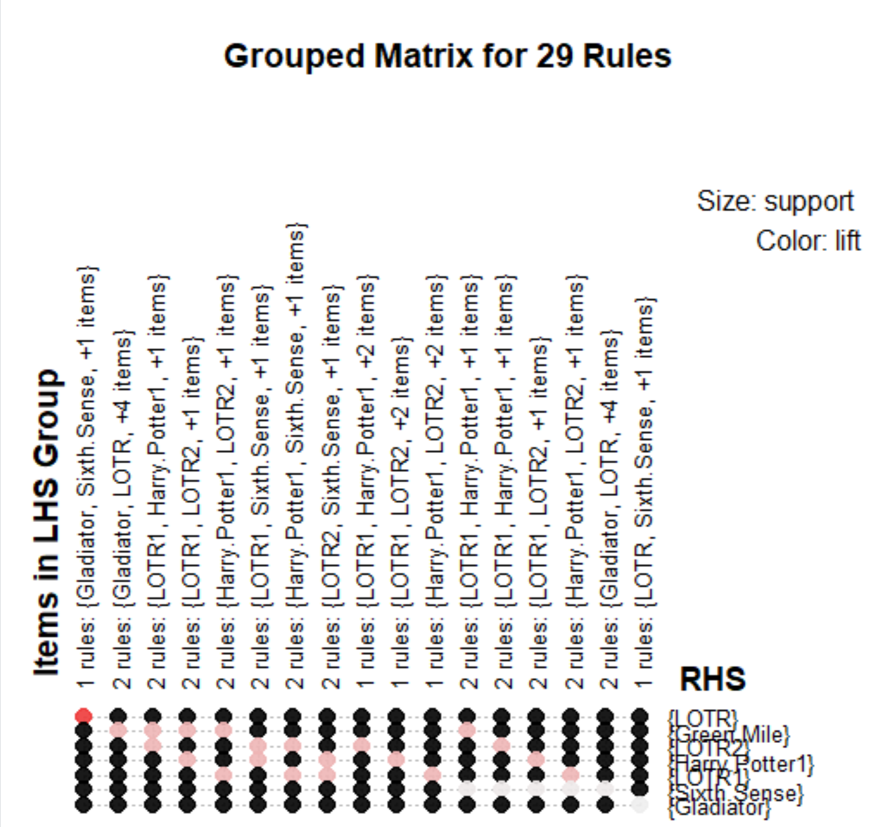

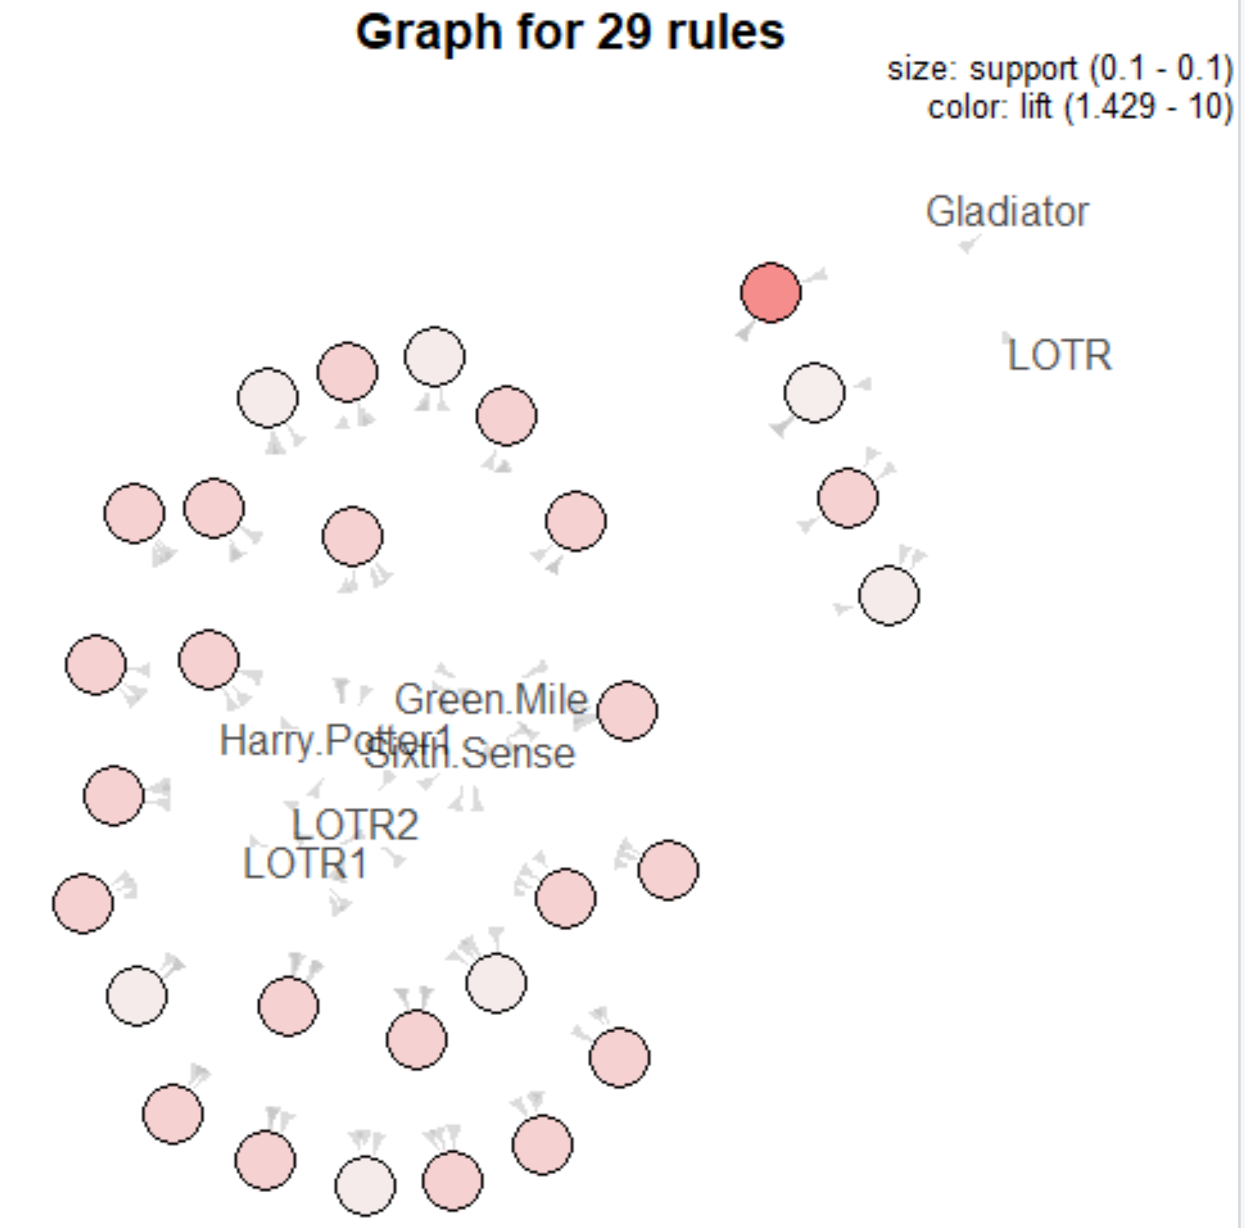

#2nd rule: Movies_rules <- apriori(as.matrix(Movies_data[,6:15]),parameter = list(support = 0.02,confidence = 0.4,minlen=3))

|  |
| --- |
| > Movies_rules <- apriori(as.matrix(Movies_data[,6:15]),parameter = list(support = 0.02,confidence = 0.4,minlen=3))  Apriori  Parameter specification:  confidence minval smax arem aval originalSupport maxtime support minlen maxlen  0.4 0.1 1 none FALSE TRUE 5 0.02 3 10  target ext  rules FALSE  Algorithmic control:  filter tree heap memopt load sort verbose  0.1 TRUE TRUE FALSE TRUE 2 TRUE  Absolute minimum support count: 0  set item appearances ...[0 item(s)] done [0.00s].  set transactions ...[10 item(s), 10 transaction(s)] done [0.00s].  sorting and recoding items ... [10 item(s)] done [0.00s].  creating transaction tree ... done [0.00s].  checking subsets of size 1 2 3 4 5 done [0.00s].  writing ... [74 rule(s)] done [0.00s].  creating S4 object ... done [0.00s]. |
|  |
| |  | | --- | | > | | > inspect(head(sort(Movies_rules, by = "lift")))  lhs rhs support confidence lift count  [1] {Gladiator,Green.Mile} => {LOTR} 0.1 1.0 10 1  [2] {Sixth.Sense,Gladiator,Green.Mile} => {LOTR} 0.1 1.0 10 1  [3] {Gladiator,LOTR} => {Green.Mile} 0.1 1.0 5 1  [4] {Sixth.Sense,LOTR} => {Green.Mile} 0.1 1.0 5 1  [5] {Sixth.Sense,Green.Mile} => {LOTR} 0.1 0.5 5 1  [6] {LOTR1,Harry.Potter1} => {LOTR2} 0.1 1.0 5 1 | |  | | |  | | --- | | > | |         #3rd rule: Movies_rules <- apriori(as.matrix(Movies_data[,6:15]),parameter = list(support = 0.05,confidence = 0.6,minlen=4)) |

> inspect(head(sort(Movies_rules, by = "lift")))

lhs rhs support confidence lift

[1] {Sixth.Sense,Gladiator,Green.Mile} => {LOTR} 0.1 1 10

[2] {Sixth.Sense,Gladiator,LOTR} => {Green.Mile} 0.1 1 5

[3] {LOTR1,Harry.Potter1,LOTR2} => {Green.Mile} 0.1 1 5

[4] {LOTR1,Harry.Potter1,Green.Mile} => {LOTR2} 0.1 1 5

[5] {LOTR1,LOTR2,Green.Mile} => {Harry.Potter1} 0.1 1 5

[6] {Harry.Potter1,LOTR2,Green.Mile} => {LOTR1} 0.1 1 5

count

[1] 1

[2] 1

[3] 1

[4] 1

[5] 1

[6] 1

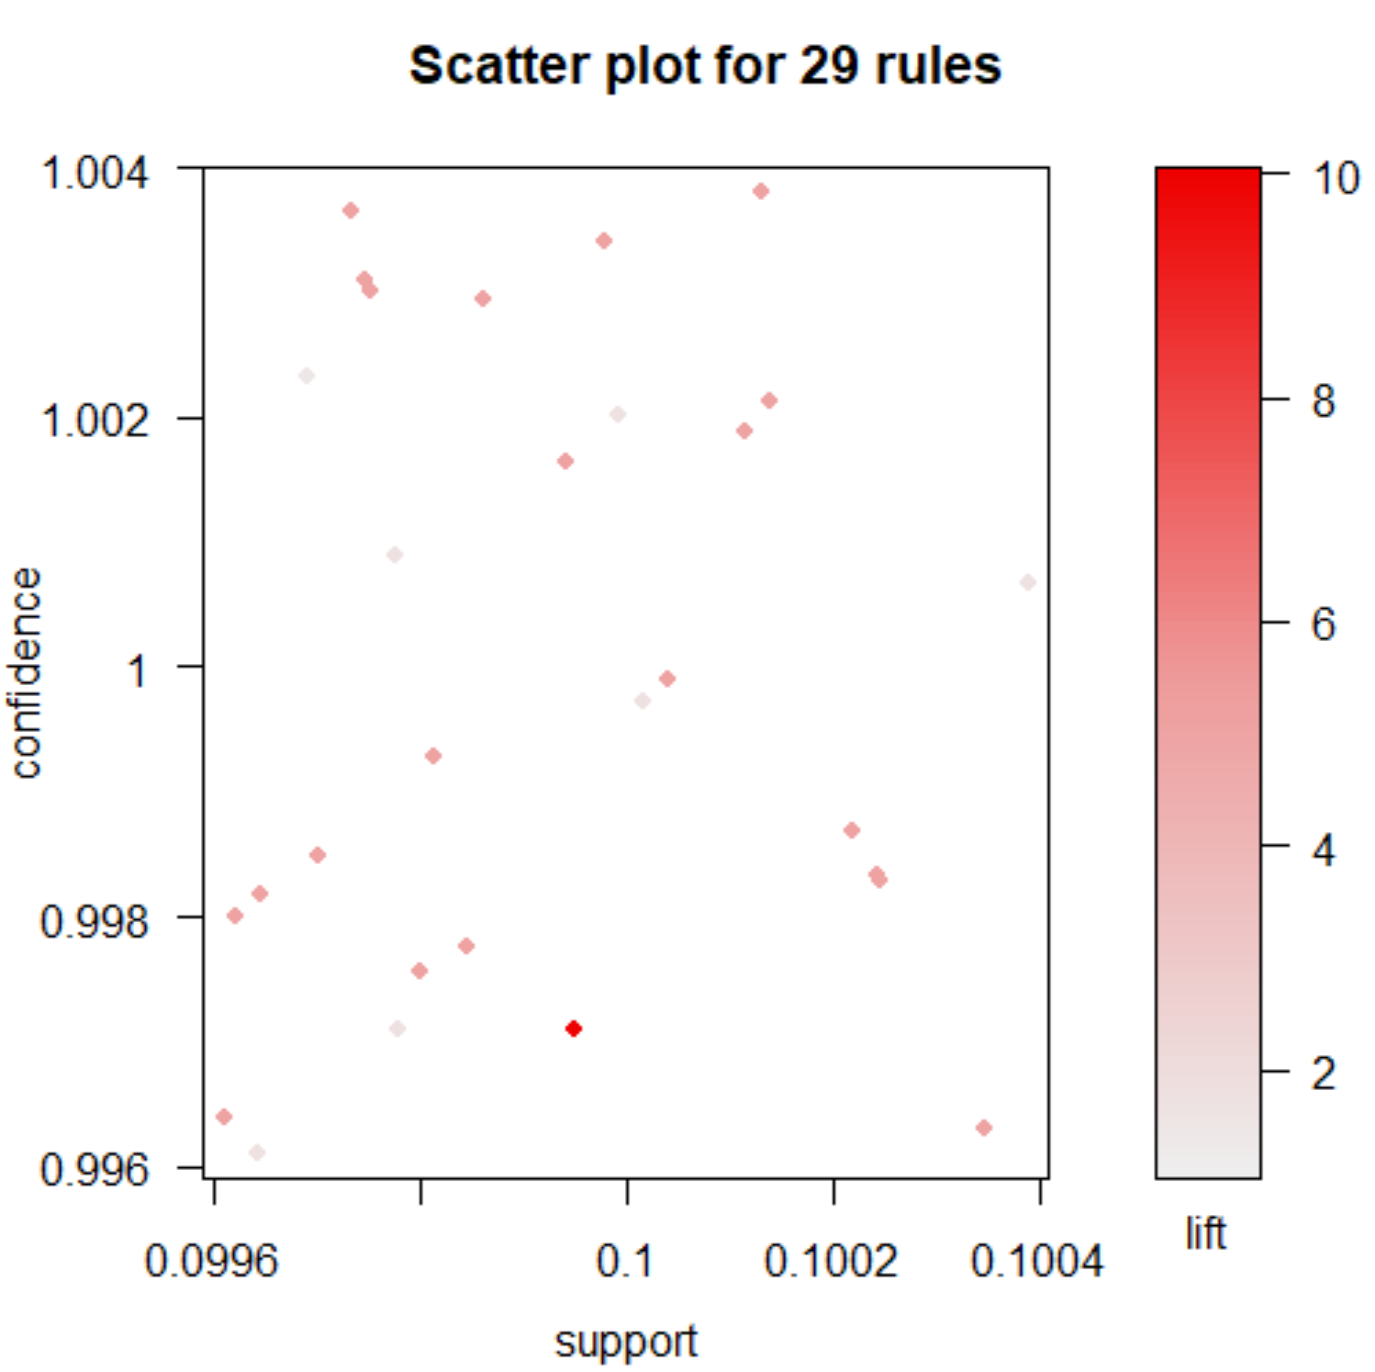

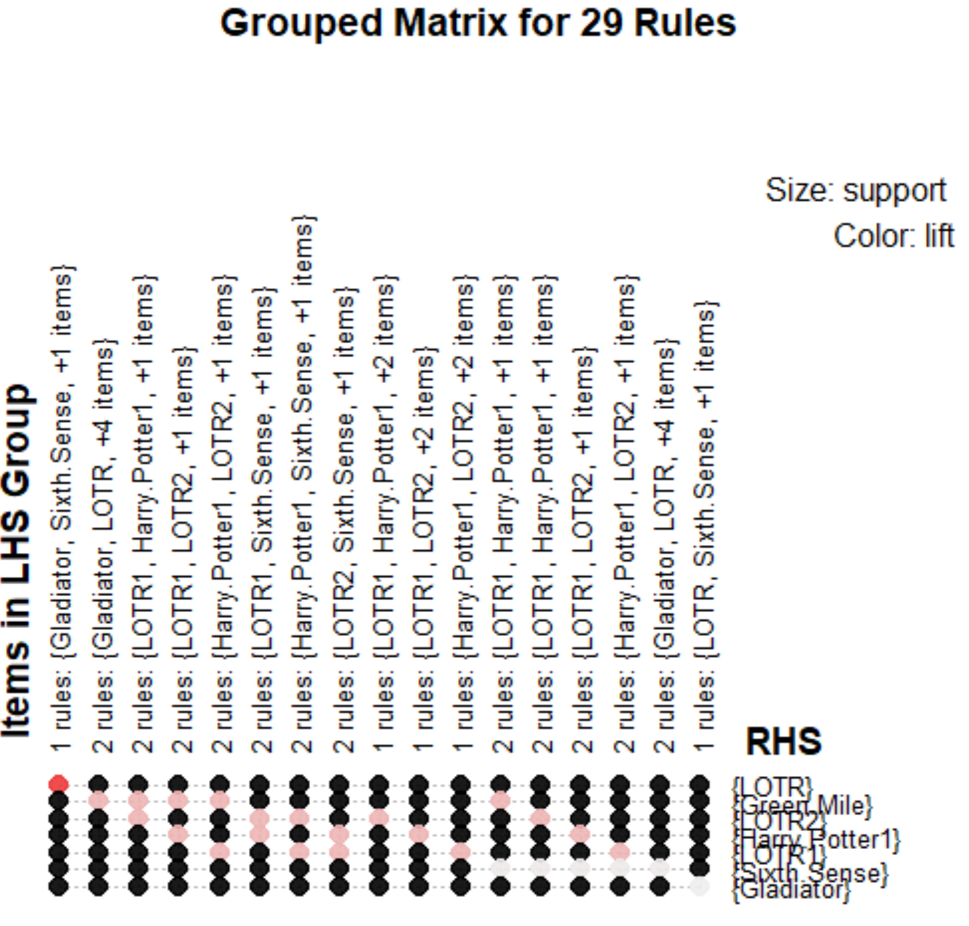

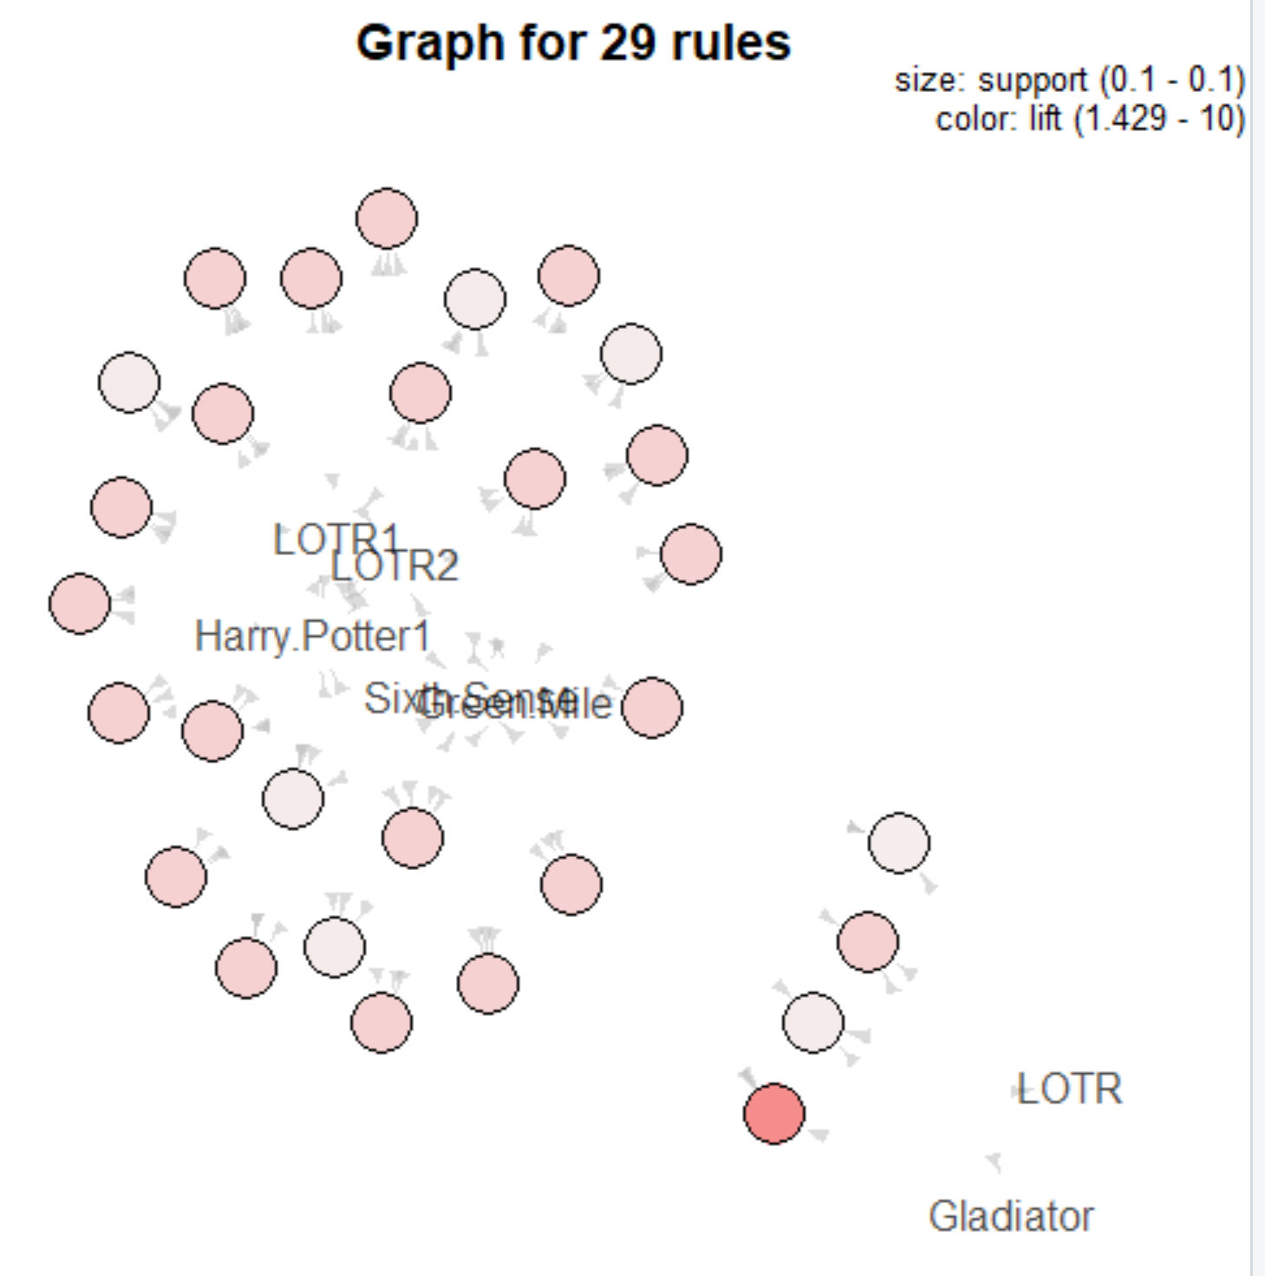

#4th rule: Movies_rules <- apriori(as.matrix(Movies_data[,6:15]),parameter = list(support = 0.02,confidence = 0.05,minlen=5))

> Movies_rules <- apriori(as.matrix(Movies_data[,6:15]),parameter = list(support = 0.02,confidence = 0.05,minlen=5))

Apriori

Parameter specification:

confidence minval smax arem aval originalSupport maxtime support minlen maxlen

0.05 0.1 1 none FALSE TRUE 5 0.02 5 10

target ext

rules FALSE

Algorithmic control:

filter tree heap memopt load sort verbose

0.1 TRUE TRUE FALSE TRUE 2 TRUE

Absolute minimum support count: 0

set item appearances ...[0 item(s)] done [0.00s].

set transactions ...[10 item(s), 10 transaction(s)] done [0.00s].

sorting and recoding items ... [10 item(s)] done [0.00s].

creating transaction tree ... done [0.00s].

checking subsets of size 1 2 3 4 5 done [0.00s].

writing ... [5 rule(s)] done [0.00s].

creating S4 object ... done [0.00s].

> inspect(head(sort(Movies_rules, by = "lift")))

lhs rhs support

[1] {Sixth.Sense,LOTR1,Harry.Potter1,LOTR2} => {Green.Mile} 0.1

[2] {Sixth.Sense,LOTR1,Harry.Potter1,Green.Mile} => {LOTR2} 0.1

[3] {Sixth.Sense,LOTR1,LOTR2,Green.Mile} => {Harry.Potter1} 0.1

[4] {Sixth.Sense,Harry.Potter1,LOTR2,Green.Mile} => {LOTR1} 0.1

[5] {LOTR1,Harry.Potter1,LOTR2,Green.Mile} => {Sixth.Sense} 0.1

confidence lift count

[1] 1 5.000000 1

[2] 1 5.000000 1

[3] 1 5.000000 1

[4] 1 5.000000 1

[5] 1 1.666667 1

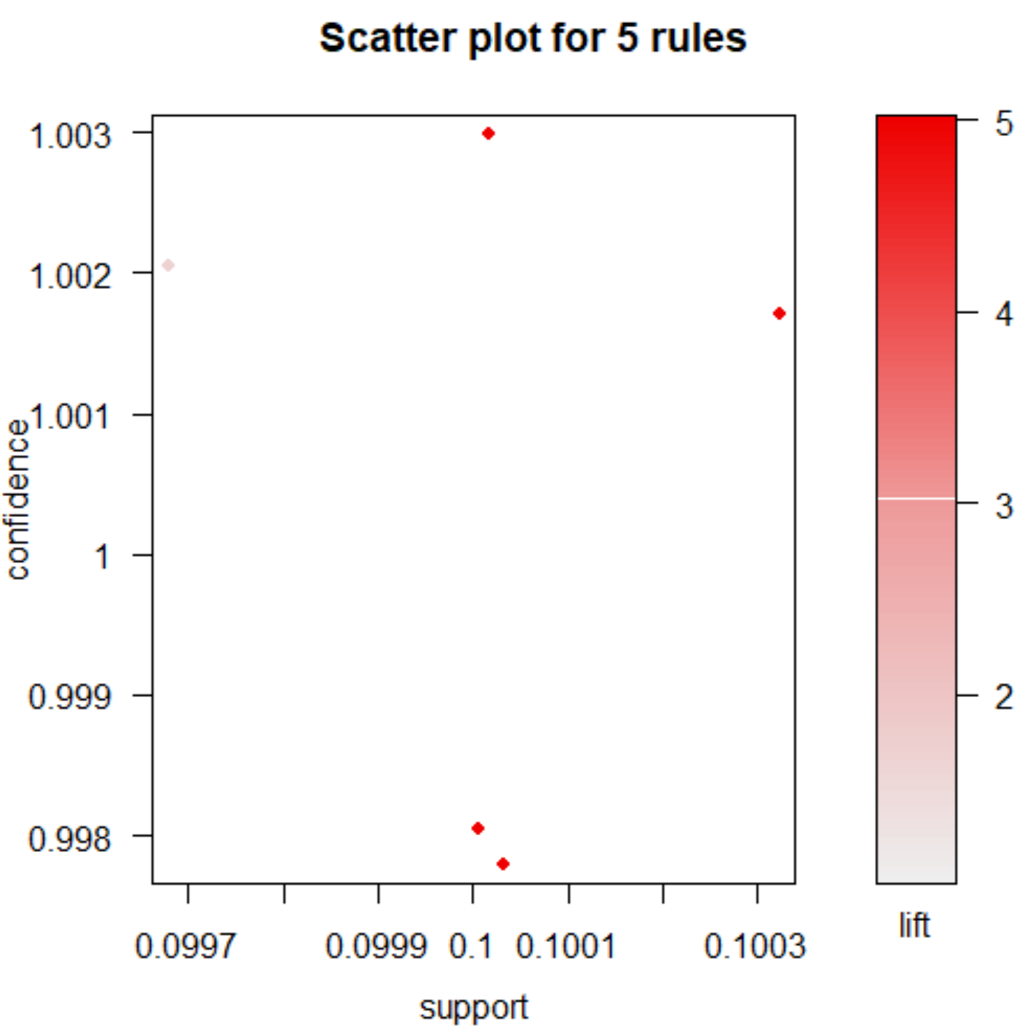

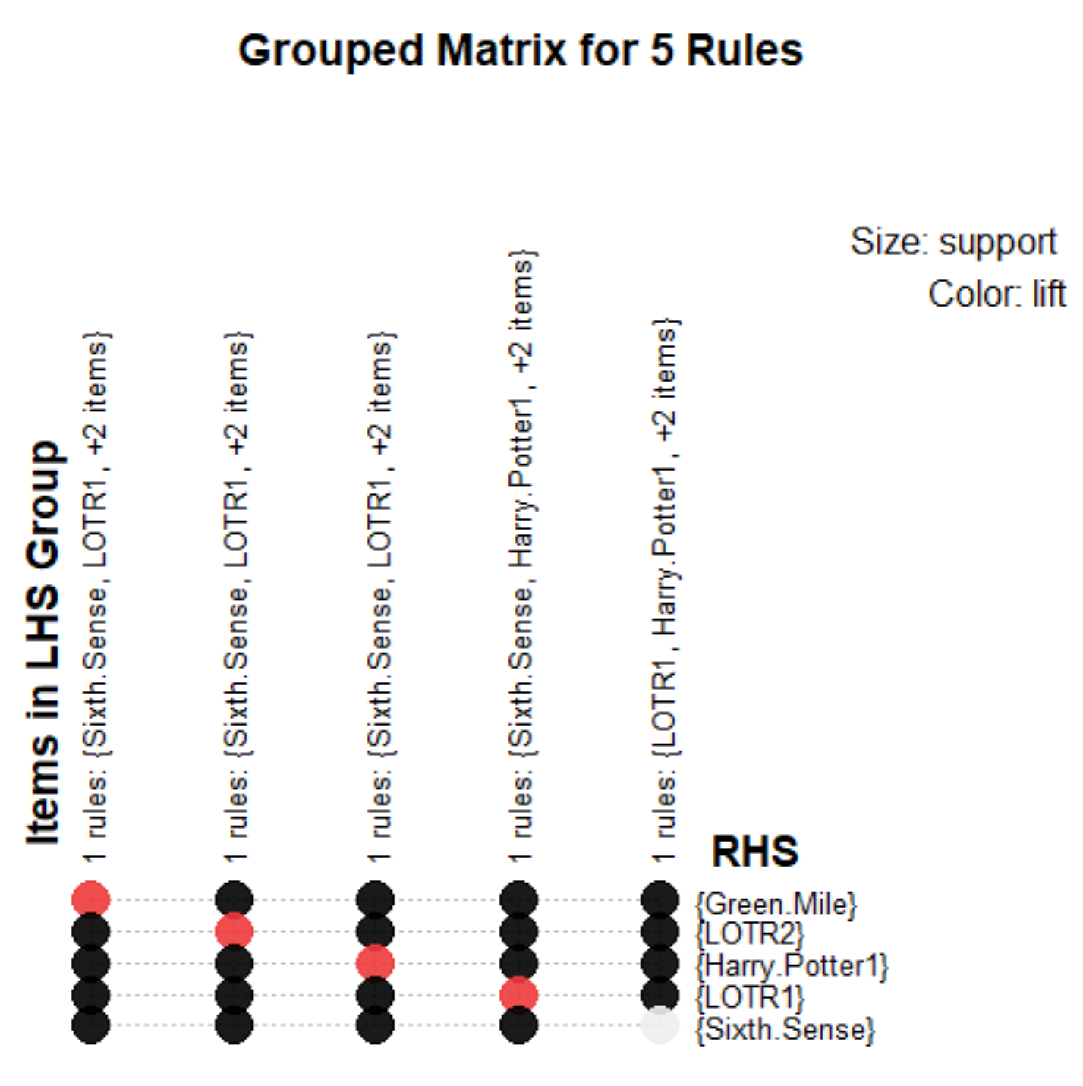

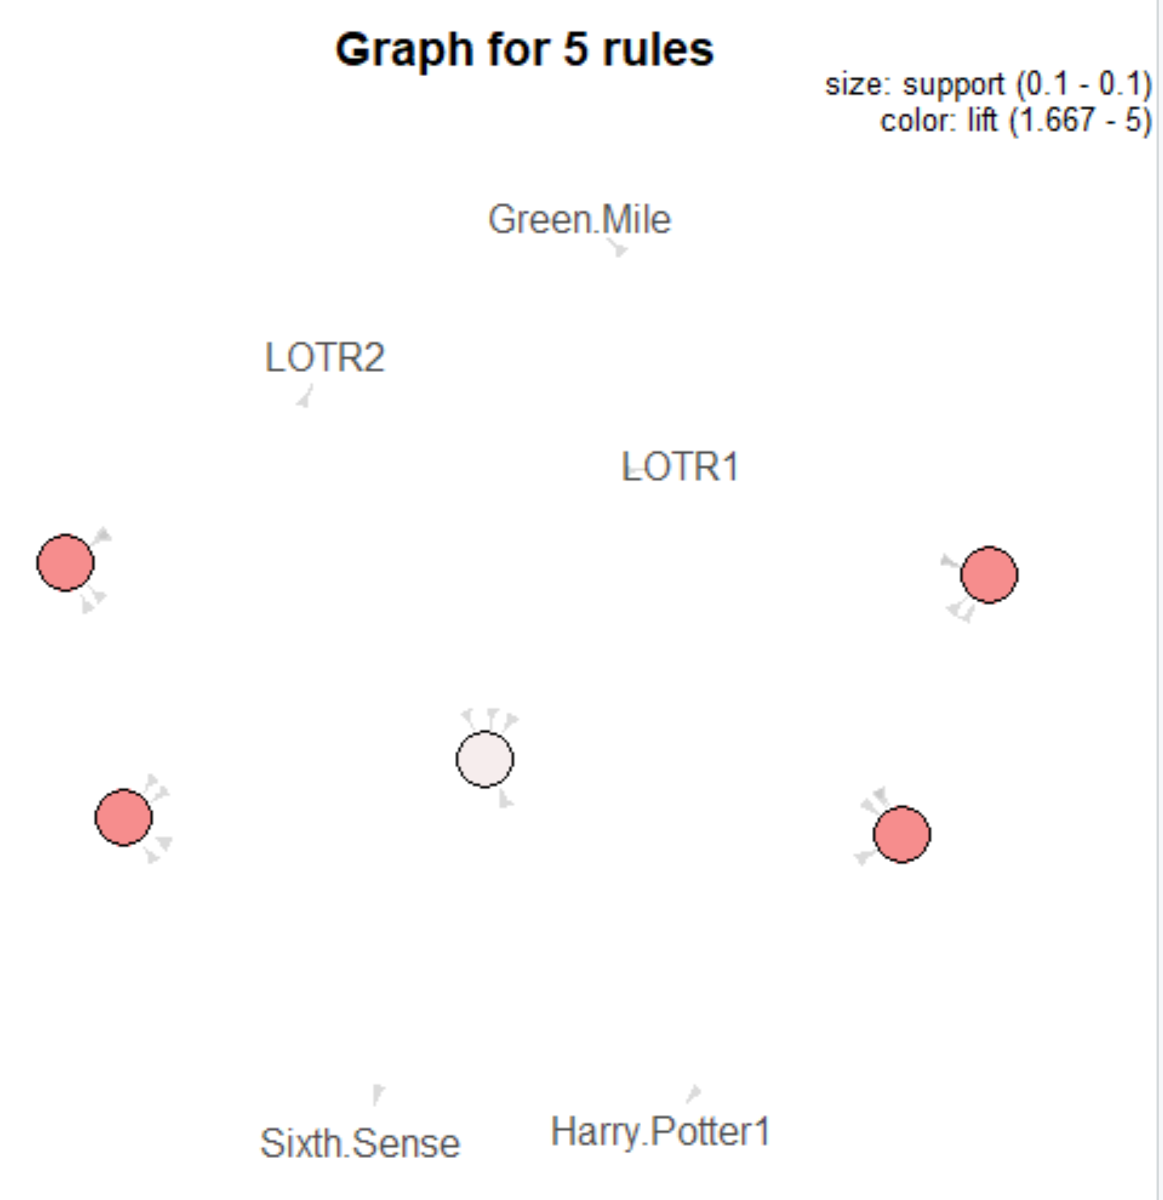

#5th rule: Movies_rules <- apriori(as.matrix(Movies_data[,6:15]),parameter = list(support = 0.09,confidence = 0.3,minlen=4))

> Movies_rules <- apriori(as.matrix(Movies_data[,6:15]),parameter = list(support = 0.09,confidence = 0.3,minlen=4))

Apriori

Parameter specification:

confidence minval smax arem aval originalSupport maxtime support minlen maxlen

0.3 0.1 1 none FALSE TRUE 5 0.09 4 10

target ext

rules FALSE

Algorithmic control:

filter tree heap memopt load sort verbose

0.1 TRUE TRUE FALSE TRUE 2 TRUE

Absolute minimum support count: 0

set item appearances ...[0 item(s)] done [0.00s].

set transactions ...[10 item(s), 10 transaction(s)] done [0.00s].

sorting and recoding items ... [10 item(s)] done [0.00s].

creating transaction tree ... done [0.00s].

checking subsets of size 1 2 3 4 5 done [0.00s].

writing ... [29 rule(s)] done [0.00s].

creating S4 object ... done [0.00s].

> inspect(head(sort(Movies_rules, by = "lift")))

lhs rhs support confidence lift

[1] {Sixth.Sense,Gladiator,Green.Mile} => {LOTR} 0.1 1 10

[2] {Sixth.Sense,Gladiator,LOTR} => {Green.Mile} 0.1 1 5

[3] {LOTR1,Harry.Potter1,LOTR2} => {Green.Mile} 0.1 1 5

[4] {LOTR1,Harry.Potter1,Green.Mile} => {LOTR2} 0.1 1 5

[5] {LOTR1,LOTR2,Green.Mile} => {Harry.Potter1} 0.1 1 5

[6] {Harry.Potter1,LOTR2,Green.Mile} => {LOTR1} 0.1 1 5

count

[1] 1

[2] 1

[3] 1

[4] 1

[5] 1

[6] 1

